Jamie Javis

CS - 499

9/22/24

Enhancement One: Software Design and Engineering

1. Briefly describe the artifact. What is it? When was it created?

For Artifact One, I have chosen to use a project from CS-340. This project is titled the “Grazioso Salvare Project” which was intended as a Web Application Dashboard that employed CRUD operations to access and store information from a database storing data. This project permits an authorized user to access a database with existing data about guests at an animal shelter. The data is then displayed in a terminal dashboard. This project was created earlier this year in the summer.

2. Justify the inclusion of the artifact in your ePortfolio. Why did you select this item? What specific components of the artifact showcase your skills and abilities in software development? How was the artifact improved?

I chose to incorporate this artifact because it was something that was created on Linux and I wanted to see how well it would work on Windows/Android. I selected this artifact to enhance it by moving the original Python web-based interface to a mobile app using Java and XML. Instead of using Mongo as the web-based interface. Unlike the interface, I added a graphical UI that incorporates buttons using the XML formats. Each XML file has a correlating Java file that controls the actions of the objects within the interface.

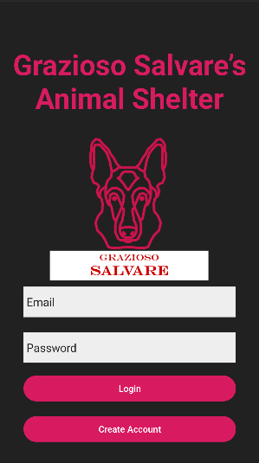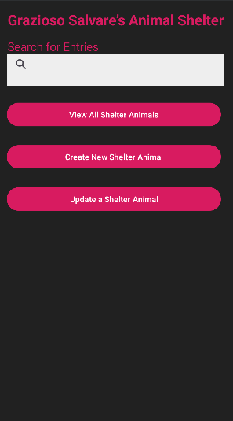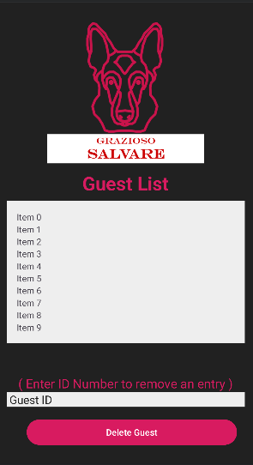

With the enhancements, I am demonstrating my skills in developing software, project management, system analysis, and professional communication. I show my ability by design user-friendly interfaces that has been enhanced for mobile devices. I have also shown my ability to generate cross-platform designs that embraces the original idea and tasks of the web application interface. I demonstrate my skill to manage a project by including my plan and dividing the tasks based on the requirements of the application such as the CRUD operations.

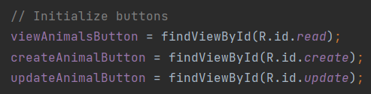

Lastly, I plan to use any instructor feedback to expand the planned enhancements throughout the enhancement process.

3. Did you meet the course outcomes you planned to meet with this enhancement in Module One? Do you have any updates to your outcome-coverage plans?

Working on this project, I was able to show my abilities to design and evaluate computing solutions that solve a given problem using algorithmic principles and computer science practices and standards appropriate to its solution while managing the trade-offs involved in design choices. Below is modularity in the classes as well as encapsulation.

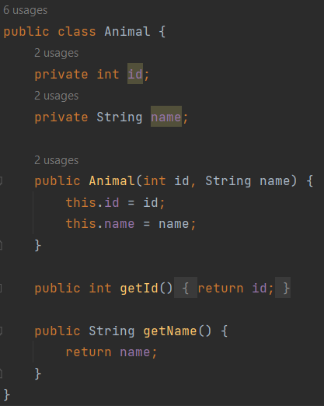

During this artifact enhancement, I have also shown my ability to design, develop, and deliver professional-quality oral, written, and visual communications that are coherent, technically sound, and appropriately adapted to specific audiences and contexts.

4. Reflect on the process of enhancing and modifying the artifact. What did you learn as you were creating it and improving it? What challenges did you face?

Reflecting on the course of enhancing and modifying the artifact, I learned a great deal about cross-platform development, user interface design, and the particulars of working with different programming languages and environments. Transitioning the project from a Linux-based web application to a mobile app for Windows/Android required me to understand the distinctions of different platforms and languages. I had to guarantee data consistency, efficient CRUD operations, and maintain the core functionality of the original application while adjusting it to the new setting. Developing a graphical user interface with XML for the mobile app aided me in understanding the importance of user-centric design. I learned how to create an intuitive and visually appealing interface model that improves user experience. The progression of linking XML layouts with Java code to handle user interactions expanded my understanding of event-driven programming. Designing a mobile UI that represented the functionalities of the original web application while delivering a better user experience was challenging as well due to the lack of a visual UI in the original. I had to ensure that the app was user-friendly and met the expectations of mobile users, which is different from web user interfaces.